**MICROSPECTRA SOFTWARE TECHNOLOGIES PVT.LTD.**

Name of the Industry: Microspectra Software Technologies Private Limited

Name of the Student: Aakansha RajenderSingh Thakur

Branch of Engineering: Computer Engineering

Name of Polytechnic: Government Polytechnic Khamgaon.

**…………………………………………………………………………………………………**

**Case Study**

**Objective: -**

To understand Future Emerging computing [industry 4.0] and need of Society Implementation applications.

**Areas**: Hospitality Agriculture Industry Real Estate Education etc.

Prepare 2 to 3 pages report on each case study

**CASE STUDY:**

1. To study Artificial Intelligence its needs & Applications in various domain.

**1.1 Artificial Intelligence**

According to the father of Artificial Intelligence, John McCarthy, it is “The science and engineering of making intelligent machines, especially intelligent computer programs”.

Artificial Intelligence is a way of making a computer, a computer-controlled robot, or a software think intelligently, in the similar manner the intelligent humans think.

AI is accomplished by studying how human brain thinks, and how humans learn, decide, and work while trying to solve a problem, and then using the outcomes of this study as a basis of developing intelligent software and systems.

Artificial Intelligence, defined as intelligence exhibited by machines, has many applications in today's society. More specifically, it is Weak AI, the form of AI where programs are developed to perform specific tasks, that is being utilized for a wide range of activities including medical diagnosis, electronic trading platforms, robot control, and remote sensing. AI has been used to develop and advance numerous fields and industries, including finance, healthcare, education, transportation, and more.

AI for Good is an ITU initiative supporting institutions employing AI to tackle some of the world's greatest economic and social challenges. For example, the University of Southern California launched the Center for Artificial Intelligence in Society, with the goal of using AI to address socially relevant problems such as homelessness. At Stanford, researchers are using AI to analyse satellite images to identify which areas have the highest poverty levels.

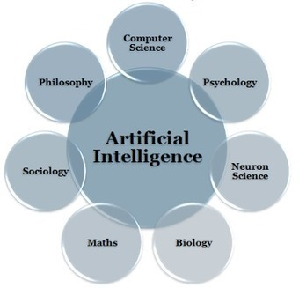

**Fig.1.1 Artificial Intelligence**

**1.2 Goals of AI**

* To Create Expert Systems:

The systems which exhibit intelligent behavior, learn, demonstrate, explain, and advice its users.

* To Implement Human Intelligence in Machines:

Creating systems that understand, think, learn, and behave like humans.

**1.3 Needs of Artificial Intelligence:**

An executive guide to artificial intelligence, from machine learning and general AI to neural networks.

AI is ubiquitous today, used to recommend what you should buy next online, to understand what you say to virtual assistants such as Amazon's Alexa and Apple's Siri, to recognise who and what is in a photo, to spot spam, or detect credit card fraud.

Artificial general intelligence is very different, and is the type of adaptable intellect found in humans, a flexible form of intelligence capable of learning how to carry out vastly different tasks, anything from haircutting to building spreadsheets, or to reason about a wide variety of topics based on its accumulated experience. This is the sort of AI more commonly seen in movies, the likes of HAL in 2001 or Skynet in The Terminator, but which doesn't exist today and AI experts are fiercely divided over how soon it will become a reality.

AI systems will typically demonstrate at least some of the following behaviours associated with human intelligence: planning, learning, reasoning, problem solving, knowledge representation, perception, motion, and manipulation and, to a lesser extent, social intelligence and creativity. **1.4 Applications of AI:**

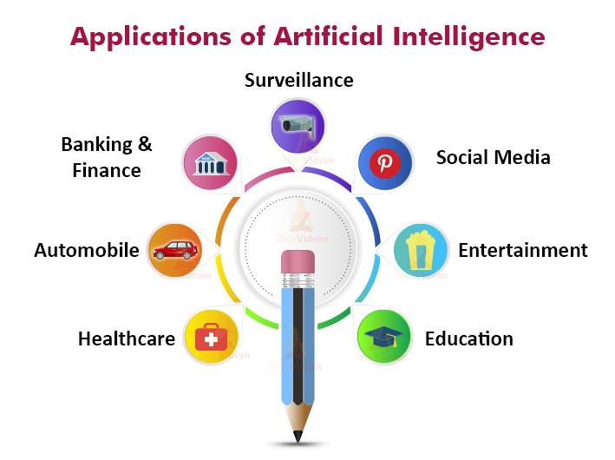

**Fig.1.4 Application of Artificial Intelligence**

2. To study 3D Printing Technology its needs & Applications in various domain.

**2.1 3D Printing Technology:**

3D printing, or additive manufacturing, is the construction of a three-dimensional object from a CAD model or a digital 3D model. The term "3D printing" can refer to a variety of processes in which material is deposited, joined or solidified under computer control to create a three-dimensional object, with material being added together (such as liquid molecules or powder grains being fused together), typically layer by layer.

In the 1980s, 3D printing techniques were considered suitable only for the production of functional or aesthetic prototypes, and a more appropriate term for it at the time was rapid prototyping. As of 2019, the precision, repeatability, and material range of 3D printing has increased to the point that some 3D printing processes are considered viable as an industrial-production technology, whereby the term additive manufacturing can be used synonymously with 3D printing. One of the key advantages of 3D printing is the ability to produce very complex shapes or geometries that would be otherwise impossible to construct by hand, including hollow parts or parts with internal truss structures to reduce weight. Fused deposition modeling, or FDM, is the most common 3D printing process in use as of 2018.

There are many different branded 3D printing processes that can be grouped into seven categories

* Vat photopolymerization
* Material jetting
* Binder jetting
* Powder bed fusion
* Material extrusion
* Directed energy deposition
* Sheet lamination

**2.2 Pros and Cons of 3D Printing**

* Freedom of Design. 3D printing boasts the ability to produce complex geometry that machining and injection moulding may struggle with or may simply not be able to make.
* Rapid Prototyping.
* Print on Demand.
* Lighter, Stronger Parts.
* Waste Reduction.
* Speed.
* Cost-Effective.
* Accessibility.

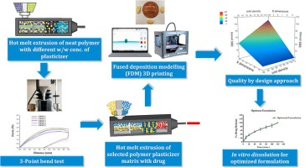

**Fig.2.2 3D Printing Technology**

**2.3 Needs of 3D Printing**

3D printing is inexpensive prosthetics, creating spare parts, rapid prototyping, creating personalized items and manufacturing with minimum waste. The technology is useful and thanks to its widespread availability as well as further development will be even more useful in the future.

**2.4 The Top Five 3D Printing Applications**

* Education. Every day, more schools are incorporating 3D printing methods into their curriculums.
* Prototyping and Manufacturing. 3D printing was first developed as a means for faster prototyping.
* Medicine.
* Construction.
* Art and Jewellery.

3. To study Internet of Things its needs & Applications in various domain.

**3.1 Internet of Things:**

The Internet of Things is an emerging topic of technical, social, and economic significance. Consumer products, durable goods, cars and trucks, industrial and utility components, sensors, and other everyday objects are being combined with Internet connectivity and powerful data analytic capabilities that promise to transform the way we work, live, and play. Projections for the impact of IoT on the Internet and economy are impressive, with some anticipating as many as 100 billion connected IoT devices and a global economic impact of more than $11 trillion by 2025.

The “INTERNET OF THINGS(IOT)” refers to the ever-growing network of physical objects that features an IP address for Internet Connectivity, and the feature an IP address for Internet connectivity, and the communication that occurs between these objects and other Internet enabled devices and systems.

In simple words, IOT is an ecosystem of connected physical objects that are accessible through the Internet.

**3.2 Scope of IOT**

IOT can connect devices embedded in various systems to the internet. When devices/objects can represent themself digitally, they can be controlled from anywhere.

The connectivity then helps us capture more data from more places, ensuring more ways of increasing efficiency.

**3.3 Needs of IOT:**

|  |  |
| --- | --- |
|  |  |

**Fig 3.3 IOT**

**3.4. Application of IOT**

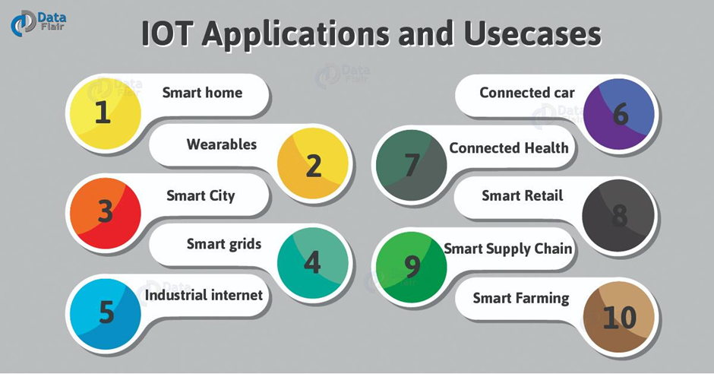

**Fig 3.4. Application of IOT**

4. To Study Machine Learning its needs & Applications in various domain.

**4.1 Machine Learning**

Machine learning (ML) is the study of computer algorithms that improve automatically through experience. It is seen as a subset of artificial intelligence. Machine learning algorithms build a mathematical model based on sample data, known as "training data", in order to make predictions or decisions without being explicitly programmed to do so. Machine learning algorithms are used in a wide variety of applications, such as email filtering and computer vision, where it is difficult or infeasible to develop conventional algorithms to perform the needed tasks.

Machine learning is closely related to computational statistics, which focuses on making predictions using computers. The study of mathematical optimization delivers methods, theory and application domains to the field of machine learning. Data mining is a related field of study, focusing on exploratory data analysis through unsupervised learning. In its application across business problems, machine learning is also referred to as predictive analytics.

**4.2 Needs of Machine Learning**

Data is the lifeblood of all business. Data-driven decisions increasingly make the difference between keeping up with competition or falling further behind. Machine learning can be the key to unlocking the value of corporate and customer data and enacting decisions that keep a company ahead of the competition.

Simply put, machine learning allows the user to feed a computer algorithm an immense amount of data and have the computer analyse and make data-driven recommendations and decisions based on only the input data.

Training is the most important part of Machine Learning. Choose your features and hyper parameters carefully. Machines don't take decisions, people do. Data cleaning is the most important part of Machine Learning

Also, the goal of mechanics is to put up the production and earnings sales with less time and expenses. Machines are necessary in our life, because, all society needs then. Sometimes, the machines are dangerous and replaced labor but without these we cannot live; for this reason a mechanical engineer is very important.

**4.3 Applications of Machine Learning**

There are many applications for machine learning, including:

* Agriculture
* Anatomy
* Adaptive websites
* Affective computing
* Banking
* Bioinformatics
* Brain–machine interfaces
* Cheminformatics
* Citizen science
* Computer networks
* Computer vision
* Credit-card fraud detection
* Data quality
* DNA sequence classification
* Economics
* Financial market analysis
* General game playing
* Handwriting recognition
* Information retrieval
* Insurance
* Internet fraud detection
* Machine learning control
* Machine perception
* Machine translation
* Marketing
* Medical diagnosis
* Natural language processing
* Natural language understanding
* Online advertising
* Optimization
* Recommender systems
* Robot locomotion
* Search engines
* Sentiment analysis
* Sequence mining
* Software engineering
* Speech recognition
* Structural health monitoring
* Syntactic pattern recognition
* Telecommunication
* Theorem proving
* Time series forecasting
* User behavior analytics

5. To study Data Science its needs & Applications in various domain.

**5.1 Data Science**

Data science is an inter-disciplinary field that uses scientific methods, processes, algorithms and systems to extract knowledge and insights from many structural and unstructured data. Data science is related to data mining, machine learning and big data. Data science is a "concept to unify statistics, data analysis, machine learning, domain knowledge and their related methods" in order to "understand and analyse actual phenomena" with data. It uses techniques and theories drawn from many fields within the context of mathematics, statistics, computer science, domain knowledge and information science. Turing award winner Jim Gray imagined data science as a "fourth paradigm" of science (empirical, theoretical, computational and now data-driven) and asserted that "everything about science is changing because of the impact of information technology" and the data deluge.

**5.2 Needs of Data Science**

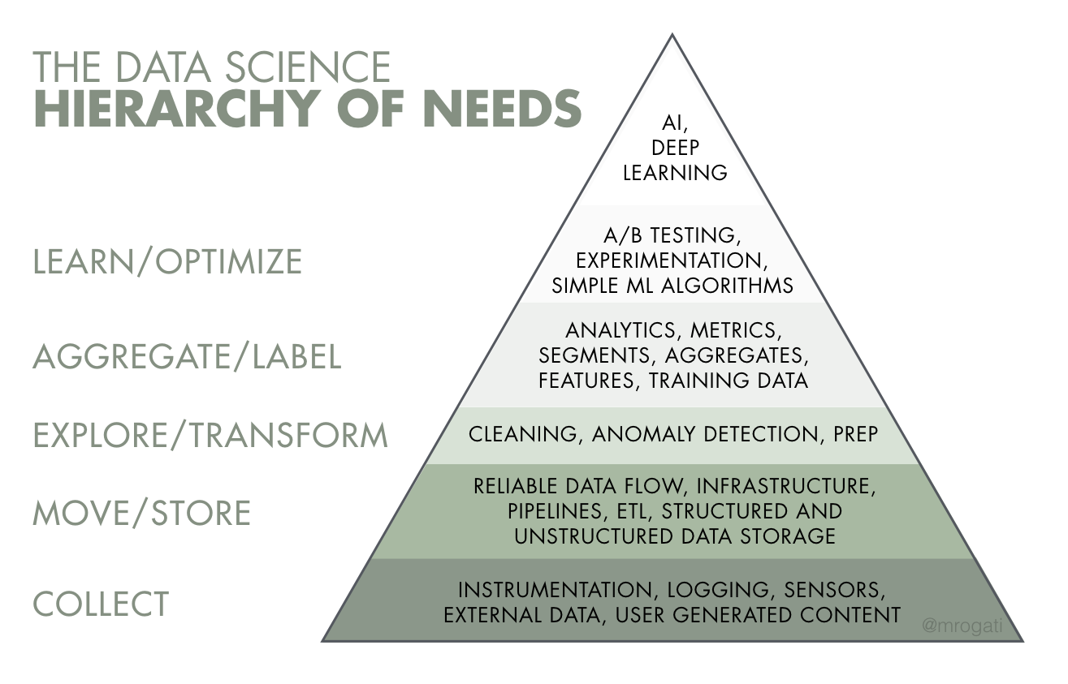

**Fig.5.2 Needs of Data Science**

**5.3 Applications of Data Science**

10 applications that build upon the concepts of Data Science, exploring various domains such as the following:

* Fraud and Risk Detection
* Healthcare
* Internet Search
* Targeted Advertising
* Website Recommendations
* Advanced Image Recognition
* Speech Recognition
* Airline Route Planning
* Gaming
* Augmented Reality

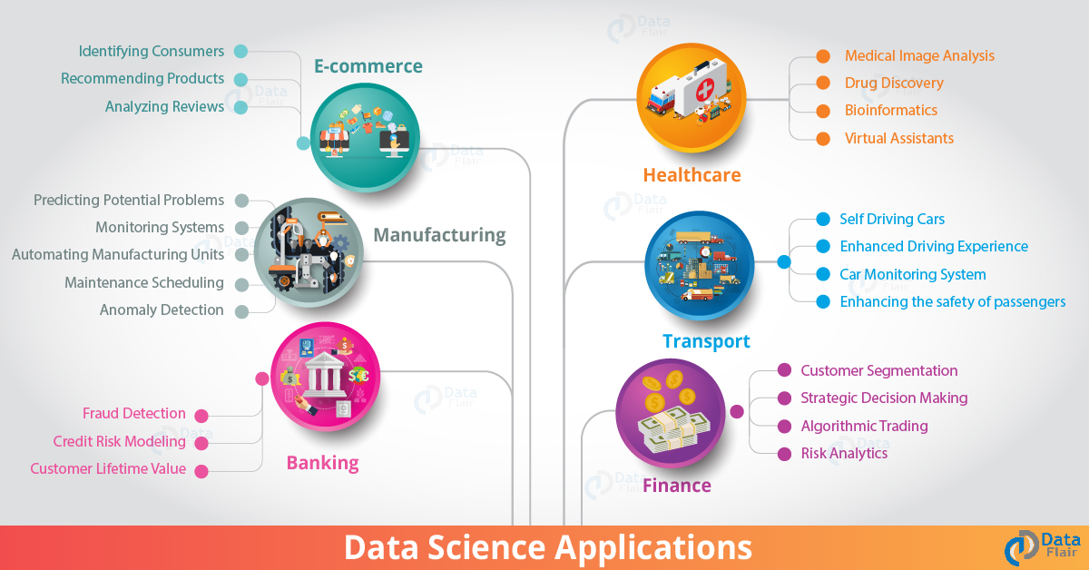

**Fig 5.2 Application of Data Science**

6. To study Data Analytics its needs & Applications in various domain.

**6.1 Data Analytics**

Data analysis is a process of inspecting, cleansing, transforming and modeling data with the goal of discovering useful information, informing conclusions and supporting decision-making. Data analysis has multiple facets and approaches, encompassing diverse techniques under a variety of names, and is used in different business, science, and social science domains. In today's business world, data analysis plays a role in making decisions more scientific and helping businesses operate more effectively.

Data mining is a particular data analysis technique that focuses on statistical modeling and knowledge discovery for predictive rather than purely descriptive purposes, while business intelligence covers data analysis that relies heavily on aggregation, focusing mainly on business information. In statistical applications, data analysis can be divided into descriptive statistics, exploratory data analysis (EDA), and confirmatory data analysis (CDA). EDA focuses on discovering new features in the data while CDA focuses on confirming or falsifying existing hypotheses. Predictive analytics focuses on application of statistical models for predictive forecasting or classification, while text analytics applies statistical, linguistic, and structural techniques to extract and classify information from textual sources, a species of unstructured data. All of the above are varieties of data analysis.

Data integration is a precursor to data analysis, and data analysis is closely linked to data visualization and data dissemination.

**6.2 Needs of Data Analysis**

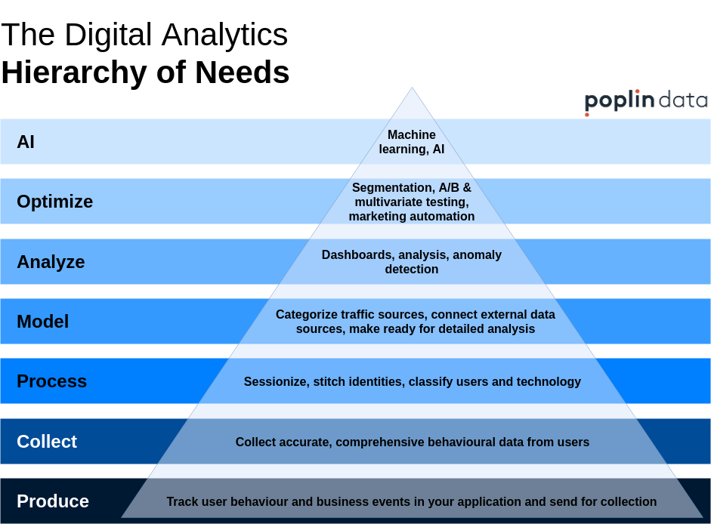

**Fig 6.2. Needs of Data Analysis**

**6.3 Applications of Data Analysis**

* Finance BA is of utmost importance to the finance sector. Data Scientists are in high demand in investment banking, portfolio management, financial planning, budgeting, forecasting, etc. For example: Companies these days have a large amount of financial data. Use of intelligent Business Analytics tools can help use this data to determine the products’ prices. Also, on the basis of historical information Business Analysts can study the trends on the performance of a particular stock and advise the client on whether to retain it or sell it.
* Marketing Studying buying patterns of consumer behaviour, analysing trends, help in identifying the target audience, employing advertising techniques that can appeal to the consumers, forecast supply requirements, etc.

For example: Use Business Analytics to gauge the effectiveness and impact of a marketing strategy on the customers. Data can be used to build loyal customers by giving them exactly what they want as per their specifications.

* **HR Professionals**

HR professionals can make use of data to find information about educational background of high performing candidates, employee attrition rate, number of years of service of employees, age, gender, etc. This information can play a pivotal role in the selection procedure of a candidate. For example: HR manager can predict the employee retention rate on the basis of data given by Business Analytics.

* **CRM**

Business Analytics helps one analyse the key performance indicators, which further helps in decision making and make strategies to boost the relationship with the consumers. The demographics, and data about other socio-economic factors, purchasing patterns, lifestyle, etc., are of prime importance to the CRM department. For example: The company wants to improve its service in a particular geographical segment. With data analytics, one can predict the customer’s preferences in that particular segment, what appeals to them, and accordingly improve relations with customers.

Manufacturing Business Analytics can help you in supply chain management, inventory management, measure performance of targets, risk mitigation plans, improve efficiency in the basis of product data, etc. For example: The Manager wants information on performance of a machinery which has been used past 10 years. The historical data will help evaluate the performance of the machinery and decide whether costs of maintaining the machine will exceed the cost of buying a new machinery.

7. To study Block chain Technology its needs & Applications in various domain.

**7.1 Blockchain Technology:**

Blockchain, sometimes referred to as Distributed Ledger Technology (DLT), makes the history of any digital asset unalterable and transparent through the use of decentralization and cryptographic hashing.

A simple analogy for understanding blockchain technology is a Google Doc. When we create a document and share it with a group of people, the document is distributed instead of copied or transferred. This creates a decentralized distribution chain that gives everyone access to the document at the same time. No one is locked out awaiting changes from another party, while all modifications to the doc are being recorded in real-time, making changes completely transparent.

Blockchain consists of three important concepts:

* Block
* Miners
* Nodes

**7.2 Needs of Blockchain Technology**

Blockchain brings trust, accountability, and transparency to digital transactions. All transactions that exist on a blockchain are shared and distributed among a network of peer-toper computers. Transactions are encrypted before they are stored and shared.

Blockchain is a better, safer way to record activity and keep data fresh, while maintaining a record of its history. The data can't be corrupted by anyone or accidentally deleted, and you benefit from both a historical trail of data, plus an instantly up-to-date record.

**7.3 Application of Blockchain Technology**

* Secure sharing of medical data
* Music royalties tracking
* Cross - border payments
* Real - time IO T operating systems
* Personal identity security
* Anti - money laundering tracking system
* Supply chain and logistics monitoring
* Voting mechanism
* Advertising insights
* Original content creation
* Cryptocurrency exchange
* Real estate processing platform

8. To study of Cyber security its needs & Applications in various domain.

**8.1 Cyber Security**

1. Cyber security or information technology security are the techniques of protecting computers, networks, programs and data from unauthorized access or attacks that are aimed for exploitation. Major areas covered in cyber security are:

1) Application

2) Information

3) Disaster Recovery

4) Network

Application security encompasses measures or counter-measures that are taken during the development life-cycle to protect applications from threats that can come through flaws in the application design, development, deployment, upgrade or maintenance. Some basic techniques used for application security are:

a) Input parameter validation

b) User/Role Authentication & Authorization

c) Session management, parameter manipulation & exception management

d) Auditing

Information security protects information from unauthorized access to avoid identity theft and to protect privacy. Major techniques used to cover this are:

a) Identification, authentication & authorization of user

b) Cryptography.

Network security includes activities to protect the usability, reliability, integrity and

safety of the network. Effective network security targets a variety of threats and stops them m entering or spreading on the network. Network security components include:

e) Anti-virus and anti-spyware,

f) Firewall, to block unauthorized access to your network,

g) Intrusion prevention systems (IPS), to identify fast-spreading threats, such as zero-day or zero-hour attacks

h) Virtual Private Networks (VPNs), to provide secure remote access.

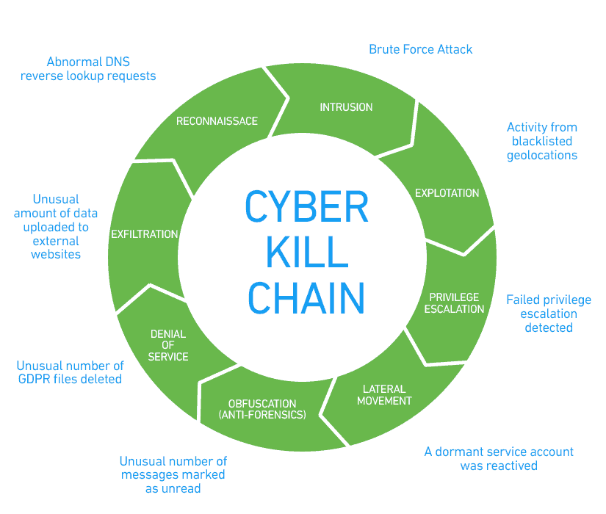

**Fig. 8.1 Cyber Kill Chain**

**8.2 Needs of Cyber Security**

Cyber security protects the data and integrity of computing assets belonging to or connecting to an organization's network. Its purpose is to defend those assets against all threat actors throughout the entire life cycle of a cyber attack.

Cybersecurity is important because it encompasses everything that pertains to protecting our sensitive data, personally identifiable information (PII), protected health information (PHI), personal information, intellectual property, data, and governmental and industry information systems from theft and damage attempted

Cyber security demands focus and dedication. Cyber security protects the data and integrity of computing assets belonging to or connecting to an organization's network. Its purpose is to defend those assets against all threat actors throughout the entire life cycle of a cyber-attack.

**8.3 Applications of Cyber Security**

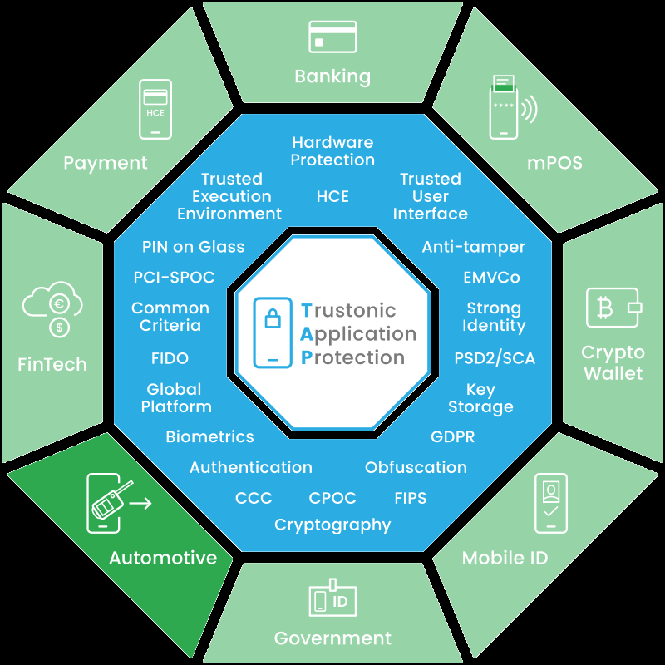

**Fig. 8.3 Applications of Cyber Security**

9. To study of Cloud computing its needs & Applications in various domain.

**9.1 Cloud Computing**

Cloud computing is the on-demand availability of computer system resources, especially data storage (cloud storage) and computing power, without direct active management by the user. The term is generally used to describe data centres available to many users over the Internet. Large clouds, predominant today, often have functions distributed over multiple locations from central servers. If the connection to the user is relatively close, it may be designated an edge server.

Clouds may be limited to a single organization (enterprise clouds), or be available to many organizations (public cloud).

Cloud computing relies on sharing of resources to achieve coherence and economies of scale.

Advocates of public and hybrid clouds note that cloud computing allows companies to avoid or minimize up-front IT infrastructure costs. Proponents also claim that cloud computing allows enterprises to get their applications up and running faster, with improved manageability and less maintenance, and that it enables IT teams to more rapidly adjust resources to meet fluctuating and unpredictable demand, providing the burst computing capability: high computing power at certain periods of peak demand.

Cloud providers typically use a "pay-as-you-go" model, which can lead to unexpected operating expenses if administrators are not familiarized with cloud-pricing models.

**9.2 Needs of Cloud Computing**

Cloud computing facilitates the access of applications and data from any location worldwide and from any device with an internet connection. Cost savings; Cloud computing offers businesses with scalable computing resources hence saving them on the cost of acquiring and maintaining them.

**9.3 Application of Cloud Computing**

Cloud service providers provide various applications in the field of art, business, data storage and backup services, education, entertainment, management, social networking, etc.

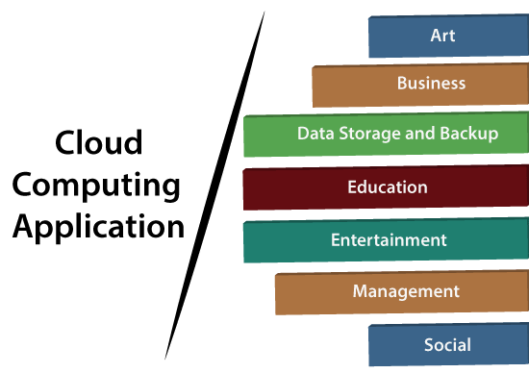

**Fig. 9.3 Applications of Cloud Computing**

10. To study Industry 4.0 its needs and List Minimum 20 IT Product based & Service based Industry.

**10.1 Industry 4.0**

Industry 4.0 is used interchangeably with the fourth industrial revolution and represents a new stage in the organization and control of the industrial value chain.

Cyber-physical systems form the basis of Industry 4.0 (e.g., ‘smart machines’). They use modern control systems, have embedded software systems and dispose of an Internet address to connect and be addressed via IoT (the Internet of Things). This way, products and means of production get networked and can ‘communicate’, enabling new ways of production, value creation, and real-time optimization.

**10.2 Needs of Industry 4.0**

The reasons why industry 4.0 is important are the benefits. It helps manufacturers with current challenges by becoming more flexible and reacting to changes in the market easier. It can increase the speed of innovation and is very consumer centered, leading to faster design processes.

Small scale industries are important because it helps in increasing employment and economic development of India. It improves the growth of the country by increasing urban and rural growth. ... The industry is a sector in which the production of goods is a segment of the economy.

**10.3 Top 20 Product Based Companies in Bengaluru India**

**1. Adobe**

Adobe Inc. was founded in December 1982 in a garage by John Warnock and Charles Geschke. Name of the company, Adobe comes from Adobe Creek in Los Altos, California, which ran behind Warnock’s house.

**2. Amazon**

Amazon does not need any introduction in today’s World. Jeff Bezos founded Amazon on July 5, 1994, in Bellevue, Washington, USA.

Some of the best products from Amazon are:

Amazon.com is the World’s # 1 e-commerce website; Cloud computing, and AI-based products, including Amazon Alexa, Amazon Fire TV, Amazon Kindle, etc.

**3. Amdocs**

Amdocs is a market leader in Telecom Domain products and services. Morris Kahn founded Amdocs in 1982 in Israel.

Amdocs (then Aurec Information & Directory Systems) developed a billing software program for phone directory companies.

**4. BMC**

Three Shell Oil employees, Scott Boulette, John J. Moores, and Dan Cloer, founded BMC in September 1980 in Houston, Texas, USA. Companies are derived from their surname initials.

**5. CISCO**

Leonard Bosack & Sandy Lerner, two Stanford University computer professional, founded Cisco in December 1984; Their concept was based on a local area network (LAN) being used to connect geographically disparate computers over a multiprotocol router system.

**6. FACEBOOK**

Facebook was founded by Mark Zuckerberg and five other Harvard fellow in 2004. Facebook is a social media, advertising, and technology company. Some of the top products are Facebook, Instagram, Messenger, WhatsApp, Watch, Portal, Oculus, Calibra, Giphy, and other products like Messenger, Watch, and Portal.

**7. Google**

Ph.D. students from Stanford University, Sergey Brin and Larry Page started Google search engine as one of their research projects in 1996. They came up with a game-changing algorithm called PageRank. The name was a misspelling of the word “googol.” Google’s initial public offering (IPO) happened in 2004. Larry Page, Sergey Brin, and Eric Schmidt decided to work at Google until 2024.

**8. Hewlett-Packard (HP)**

In 1938, Packard and Hewlett, with 538 dollars, started a part-time job in a rented garage. In 1939 they formed a partnership and decided the name of the company Hewlett-Packard. HP incorporated in August 1947 and went public in November 1957. In a critical piece of their circuit, they used a small incandescent light bulb as a resistor, which is temperature-dependent.

**9. International Business Machines Corporation (IBM):**

IBM is often considered one of the best companies on the planet. In the 1880s, four technologies developed the blueprint of what International Business Machines (IBM) is today.

**10. Intel**

Intel was founded in 1968 Arthur Rock, along with Gordon E. Moore and Robert Noyce. It is a semiconductor chip manufacturing company used in computer microprocessors. They were the suppliers to computer system manufacturing companies like HP, Apple, Dell, Lenovo. Intel means intelligence information.

Some of the best products from Intel are:

SRAM and DRAM, semiconductor chipsets, motherboard chipsets, network interface controllers, integrated circuits, flash memory, graphics chips, embedded processors, and other devices used for communication and computing.

**11. Microsoft**

Bill Henry Gates and Paul Allen founded Microsoft in 1975. In the 1980’s it dominated the personal computer operating system space with MS-DOS, and currently Microsoft Windows.

Some of the best products from Microsoft are:

IntruShield, McAfee Change Control, McAfee DAT Reputation, McAfee E-Business Server, McAfee Entercept, McAfee SiteAdvisor, McAfee VirusScan.

**10.4 SERVICE BASED COMPANIES**

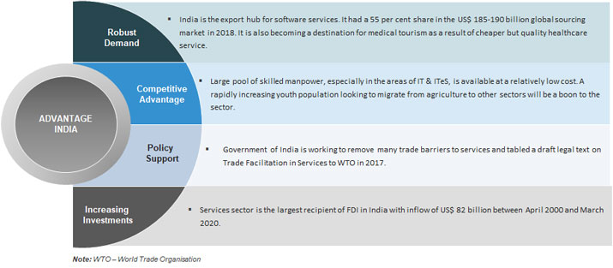

**Fig 10.4. List of top service companies**